***ASSIGNMENT***

***NumPy***

**Question 1 :**

1. If arr = np.array([1, 2, 3, 4, 5]), what happens if you execute arr[1:4] = 10?
2. For the array arr = np.array([0, 1, 2, 3, 4, 5]), what does arr[::2] return?

**Question 2:**

import numpy as np

a = np.array([[1, 2, 3],

[4, 5, 6]])

b = np.array([10, 20, 30])

What will be the output of the operation a + b? Explain how broadcasting is applied in this scenario.

**Question 3:**

Create a 1D array of random numbers and find the indices of local peaks (values that are strictly greater than their neighbors).

(A local peak is an element in an array that is greater than both its left and right neighbors.)

(Hint : create a random 1D array, and use np.where() function to put a condition, relate it to slicing and use comparisons to formulate the function.)

**Question 4:**

Create a square matrix (of dimension p ) and calculate its determinant using an inbuilt function. Now, use scalar multiplication to multiply each element of matrix by any number ,say k. Prove that that the determinant of the new matrix is k^p times the determinant of original matrix.

**Question 5:**

Create a structured array where each element has fields for a name, age, and weight. Then sort the array by age.

***P.T.O***

***Pandas:***

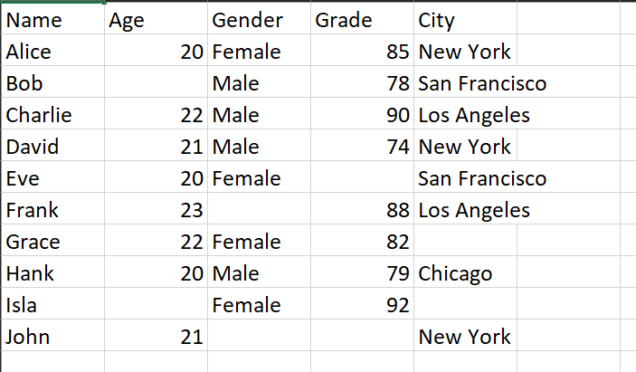

**Answer the following:**

1. How can you identify any outliers in the Age and Grade columns using pandas?
2. How can you group the students based on City and calculate the average Grade for each city?
3. How can you filter out the students who have a Grade greater than 80 and are from the city of "New York"?
4. How can you sort the dataset based on Grade in descending order and then by Age in ascending order, if two students have the same grade?
5. How can you create a new column Pass/Fail, which categorizes students as 'Pass' if their Grade is 80 or above and 'Fail' otherwise?